**Advanced SQL Mandatory hands on exercises**

**Exercise 1: Ranking and Window Functions**

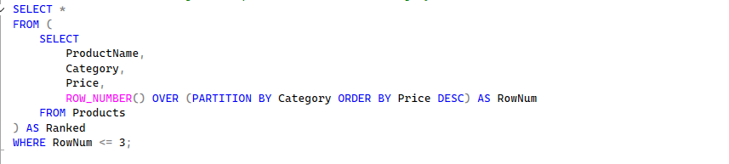

**Output table-**

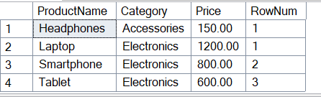

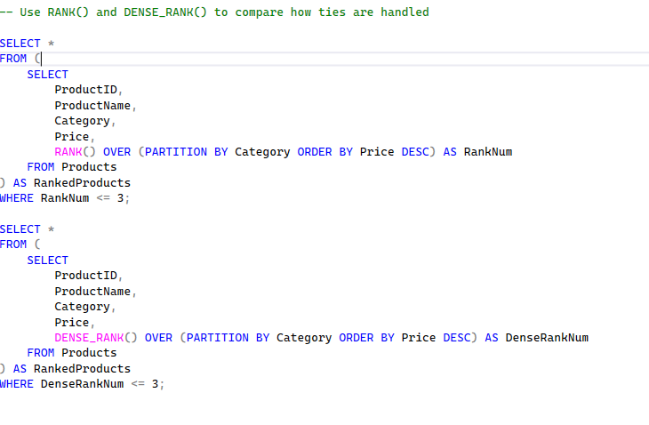

**Output-**

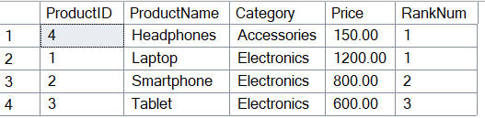

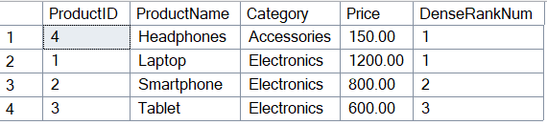

**Exercise 1: Create a Stored Procedure**

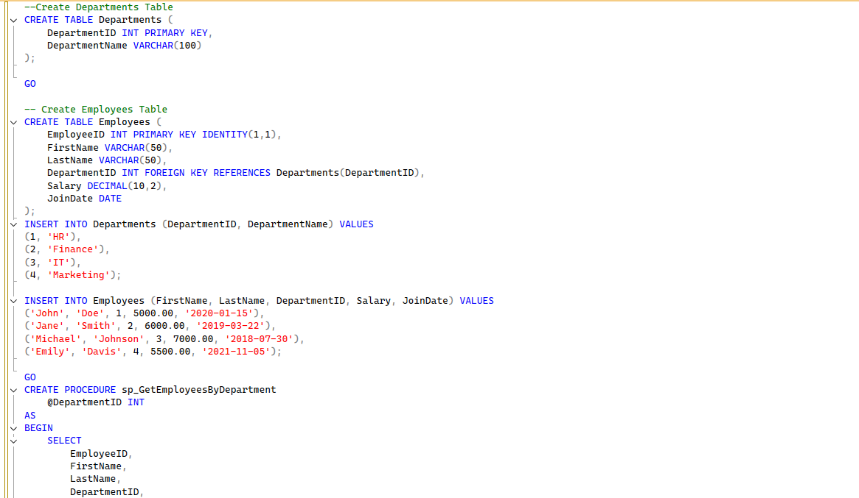

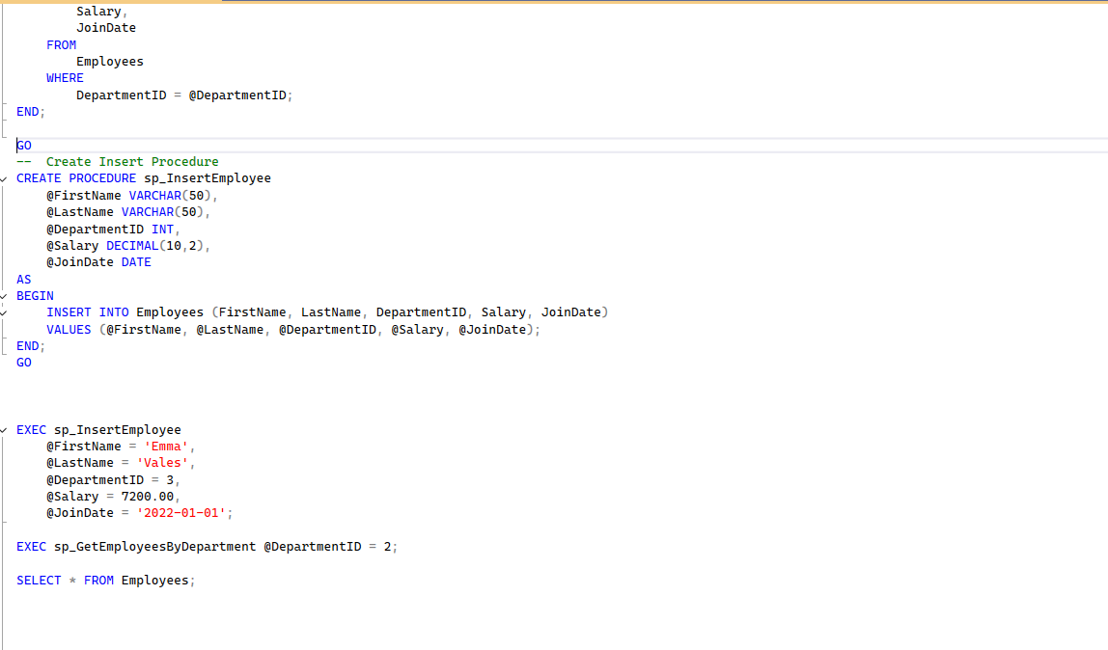

**Output-**

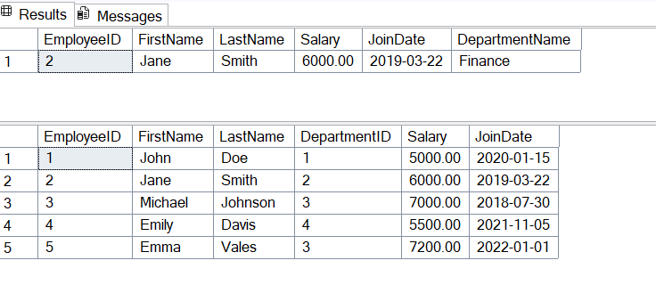

**Exercise 5: Return Data from a Stored Procedure**

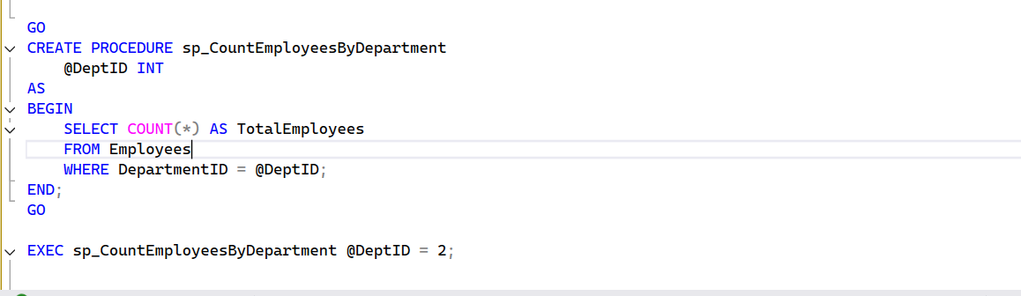

**Output-  
**